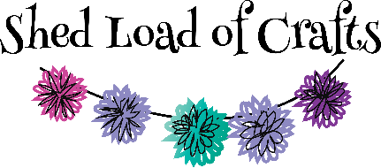

Workshop Booking Terms & Conditions
- All workshops to be paid for in advance either by cash or card in the shop or Bank Transfer to Shed Load of Crafts, Barclays Account No 00122424 Sort code 204545 with your name and workshop as reference.
- Bookings will be confirmed once full payment is received and by making the full payment you will have agreed to all the terms and conditions.
- Full refunds will be given if cancelled more than 7 days before date of workshop. Or you find someone else to take your place or if we can advertise your space and fill it.
- For Mystery Craft Night & Art group sessions if you cancel between the 7th and 4th day before the event, we will refund 50% of fee.
- In all other cases no refunds will be given.
- If we cancel a workshop/group then we are liable for the refund of the fees only, not for any other costs incurred by yourselves.
- If workshops are booked in the 7 days prior to the event then payment will be made in full and no refunds will be given (except for Mystery Craft Night & Art Group conditions as stated above)
- All drop-in groups (Weekly crochet, Time to Craft & Paper crafting) will continue to be pay when you attend.

